**INTRODUCTION**

**What is networking?**

Networking is the word basically relating to computers and their connectivity. It is very often used in the world of computers and their use in different connections. The term networking implies the link between two or more computers and their devices, with the vital purpose of sharing the data stored in the computers, with each other. The networks between the computing devices are very common these days due to the launch of various hardware and computer software which aid in making the activity much more convenient to build and use.

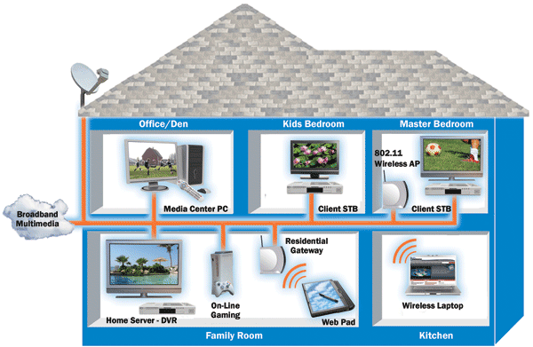

Structure of Networking between the different computers

**How networking works?**

**General Network Techniques** - When computers communicate on a network, they send out data packets without knowing if anyone is listening. Computers in a network all have a connection to the network and that is called to be connected to a network bus. What one computer sends out will reach all the other computers on the local network.

Computers on a network bus

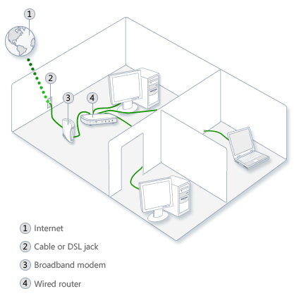

Above diagrams show the clear idea about the networking functions

For the different computers to be able to distinguish between each other, every computer has a unique ID called MAC-address (Media Access Control Address). This address is not only unique on your network but unique for all devices that can be hooked up to a network. The MAC-address is tied to the hardware and has nothing to do with IP-addresses. Since all computers on the network receives everything that is sent out from all other computers the MAC-addresses is primarily used by the computers to filter out incoming network traffic that is addressed to the individual computer.

When a computer communicates with another computer on the network, it sends out both the other computers MAC-address and the MAC-address of its own. In that way the receiving computer will not only recognize that this packet is for me but also, who sent this data packet so a return response can be sent to the sender.

**On an Ethernet network** as described here, all computers hear all network traffic since they are connected to the same bus. This network structure is called multi-drop.

One problem with this network structure is that when you have, let say ten (10) computers on a network and they communicate frequently and due to that they sends out there data packets randomly, collisions occur when two or more computers sends data at the same time. When that happens data gets corrupted and has to be resent. On a network that is heavy loaded even the resent packets collide with other packets and have to be resent again. In reality this soon becomes a bandwidth problem. If several computers communicate with each other at high speed they may not be able to utilize more than 25% of the total network bandwidth since the rest of the bandwidth is used for resending previously corrupted packets. The way to minimize this problem is to use network switches.

**Characteristics of Networking:**

The following characteristics should be considered in network design and ongoing maintenance:

1. **Availability** is typically measured in a percentage based on the number of minutes that exist in a year. Therefore, uptime would be the number of minutes the network is available divided by the number of minutes in a year.
2. **Cost**includes the cost of the network components, their installation, and their ongoing maintenance.
3. **Reliability**defines the reliability of the network components and the connectivity between them. Mean time between failures (MTBF) is commonly used to measure reliability.
4. **Security** includes the protection of the network components and the data they contain and/or the data transmitted between them.
5. **Speed**includes how fast data is transmitted between network end points (the data rate).
6. **Scalability**defines how well the network can adapt to new growth, including new users, applications, and network components.
7. **Topology**describes the physical cabling layout and the logical way data moves between components.

### Types of Networks:

Organizations of different structures, sizes, and budgets need different types of networks. Networks can be divided into one of two categories:

* peer-to-peer
* server-based networks

### Peer-to-Peer Network:

A peer-to-peer network has no dedicated servers; instead, a number of workstations are connected together for the purpose of sharing information or devices. Peer-to-peer networks are designed to satisfy the networking needs of home networks or of small companies that do not want to spend a lot of money on a dedicated server but still want to have the capability to share information or devices like in school, college, cyber cafe

### Server-Based Networks:

In server-based network data files that will be used by all of the users are stored on the one server. With a server-based network, the network server stores a list of users who may use network resources and usually holds the resources as well.  
This will help by giving you a central point to set up permissions on the data files, and it will give you a central point from which to back up all of the data in case data loss should occur.

**Network Communications:**

* Computer networks use signals to transmit data, and protocols are the languages computers use to communicate.
* Protocols provide a variety of communications services to the computers on the network.
* Local area networks connect computers using a shared, half-duplex, baseband medium, and wide area networks link distant networks.
* Enterprise networks often consist of clients and servers on horizontal segments connected by a common backbone, while peer-to-peer networks consist of a small number of computers on a single LAN.

**Advantages of Networking:**

1. **Easy Communication:**

It is very easy to communicate through a network. People can communicate efficiently using a network with a group of people. They can enjoy the benefit of emails, instant messaging, telephony, video conferencing, chat rooms, etc.

1. **Ability to Share Files, Data and Information:**

This is one of the major advantages of networking computers. People can find and share information and data because of networking. This is beneficial for large organizations to maintain their data in an organized manner and facilitate access for desired people.

1. **Sharing Hardware:**

Another important advantage of networking is the ability to share hardware. For an example, a printer can be shared among the users in a network so that there’s no need to have individual printers for each and every computer in the company. This will significantly reduce the cost of purchasing hardware.

1. **Sharing Software:**

Users can share software within the network easily. Networkable versions of software are available at considerable savings compared to individually licensed version of the same software. Therefore large companies can reduce the cost of buying software by networking their computers.

1. **Security:**

Sensitive files and programs on a network can be password protected. Then those files can only be accessed by the authorized users. This is another important advantage of networking when there are concerns about security issues. Also each and every user has their own set of privileges to prevent those accessing restricted files and programs.

1. **Speed:**

Sharing and transferring files within networks is very rapid, depending on the type of network. This will save time while maintaining the integrity of files.